An adverb is a word that modifies (describes)

• a verb: He sings *loudly*.

• an adjective: *Very* tall

• another adverb: ended *too* quickly

• even a whole sentence: *Fortunately*, I had brought an umbrella.

Adverbs often end in -ly, but some such as *fast* look like adjectives. Adverbs often answer questions such as how, when, where, why, but don’t answer questions such as who and what.

Adverb types:

Manner: He is improving *slowly*

Degree: The policeman examined the documents *thoroughly*

Place/direction: I am going *to the office*

Time/frequency: He *always* gets a good result

Sentence: *Hopefully*, I will finish the assignment.

Conjunctive: The train started late; *however*, it reached on time.

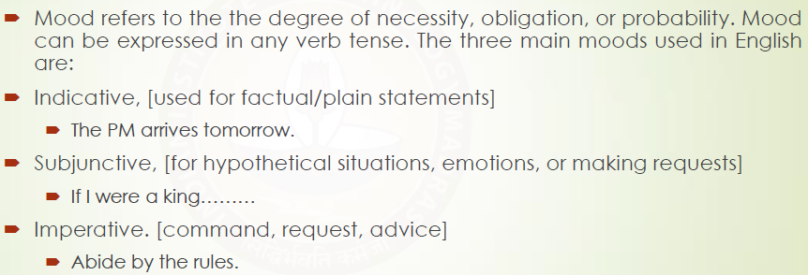

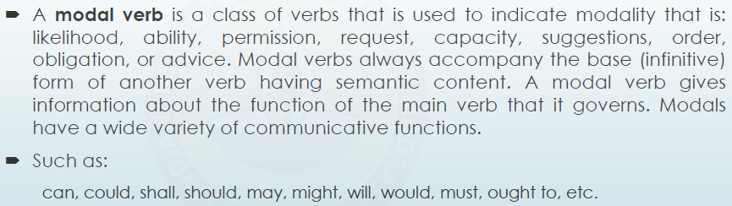

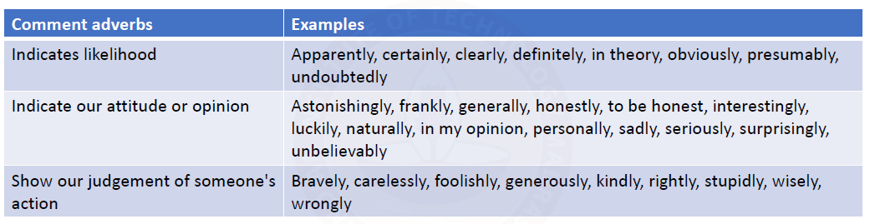

Viewpoint adverbs

Focus adverbs – Only

Examples:



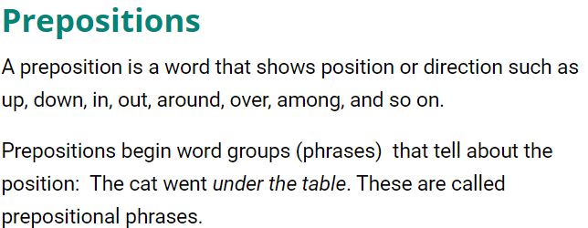

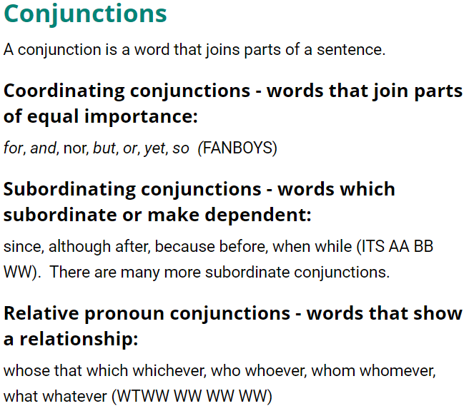

Sentence element categories

Lexical elements: Nouns, Verbs, Prepositions, Adjectives

Functional elements: Agreement (Person, Grammar), Tense(Past, Present, Future), Aspect (Indefinite, Continuous/progressive, Perfect, Perfect Continuous)

Participles can be *present* or *past*. They function as adjectives (E.g., cooked vegetables, breaking news) in general. When they function as nouns, it’s called gerund.

Present participles are formed by adding ‘ing’

Past participles are formed generally by adding ‘d’ or ‘ed’. Words that get their past participle forms by other methods are called irregular verbs. For example, was (been), were (been), bore (borne).

Relative clauses begin with a relative pronoun (Who, Which, Where, When, That). They function as a modifier and modifies a noun as adjectives do.

English tends to put plurals at the last. For example,

* Either my father or my siblings are with me at home.
* Either my siblings or my father is with me at home.
* Neither my father nor my siblings are with me at home.
* Neither my siblings nor my father is with me at home.

We use *whether*, not *if*, before a to-infinitive.

* I’m not sure whether to get a new laptop.

After a preposition, we use whether not if.

* There are doubts about whether the decision was fair.

Whether can be followed by ‘or not’, but *if* does not occur in such cases.

* The question is whether or not we have the right to interfere.

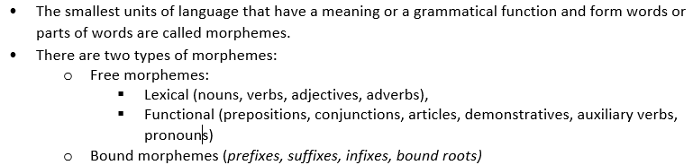

Word formation:

Clipping: ad (advertisement), phone(telephone), flu (influenza), advertorial(advertisement and editorial)

Acronymy: SCUBA (self-contained underwater breathing apparatus)

Blending: Cyborg, Guesstimate

Back formation: Postpone, Resurrection

Borrowing: Jungle

Coinage: Xerox

Compounding: Breakfast, Babysit

Derivation: Kindness, Drinkable